Exercise – 6 Configuring Beans with Annotations

Name: Shubham Sangram Bej

Aim
To configure Spring beans using annotations and enable automatic component scanning in the Library Management application.

Scenario
The Library Management application requires annotation-based bean configuration to simplify dependency management and reduce XML configuration.

Objective
- Enable component scanning.
- Configure beans using annotations.
- Use @Repository and @Service.
- Perform automatic dependency injection.
- Verify annotation-based configuration.

Software Requirements
- Java JDK 21
- Apache Maven
- Spring Framework 5.3.39
- IntelliJ IDEA

Theory
Spring Framework provides stereotype annotations such as @Repository, @Service, and @Component to automatically detect and register classes as Spring beans. Instead of defining beans manually in the XML configuration file, component scanning searches the specified package and creates bean instances automatically.
In this exercise, the BookRepository class is marked with the @Repository annotation, while the BookService class is marked with the @Service annotation. The dependency between these classes is managed automatically using the @Autowired annotation. Component scanning is enabled in applicationContext.xml, allowing Spring to detect and configure all annotated classes.

Procedure
- Created a Maven project.
- Added the Spring Context dependency.
- Created the BookRepository class.
- Annotated the repository class using @Repository.
- Created the BookService class.
- Annotated the service class using @Service.
- Added the @Autowired annotation for automatic dependency injection.
- Enabled component scanning in applicationContext.xml.
- Loaded the Spring IoC Container.
- Retrieved the BookService bean and verified the annotation-based configuration.

Files Used
- BookRepository.java
- BookService.java
- LibraryManagementApplication.java
- applicationContext.xml
- pom.xml

Output

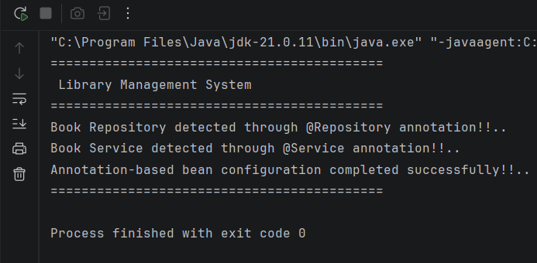

Screenshots
- Project Structure
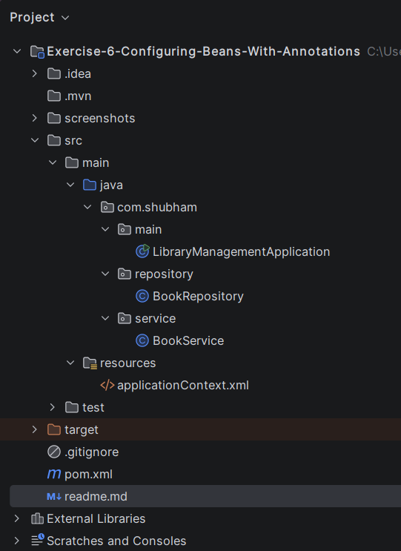

- pom.xml
<?xml version="1.0" encoding="UTF-8"?>
<project xmlns="http://maven.apache.org/POM/4.0.0"
xmlns:xsi="http://www.w3.org/2001/XMLSchema-instance"
xsi:schemaLocation="
http://maven.apache.org/POM/4.0.0
https://maven.apache.org/xsd/maven-4.0.0.xsd">
<modelVersion>4.0.0</modelVersion>
<groupId>com.shubham</groupId>
<artifactId>exercise-6-configuring-beans-with-annotations</artifactId>
<version>1.0-SNAPSHOT</version>
<properties>
<maven.compiler.source>21</maven.compiler.source>
<maven.compiler.target>21</maven.compiler.target>
<spring.version>5.3.39</spring.version>
</properties>
<dependencies>
<dependency>
<groupId>org.springframework</groupId>
<artifactId>spring-context</artifactId>
<version>${spring.version}</version>
</dependency>
</dependencies>
</project>

- BookRepository.java
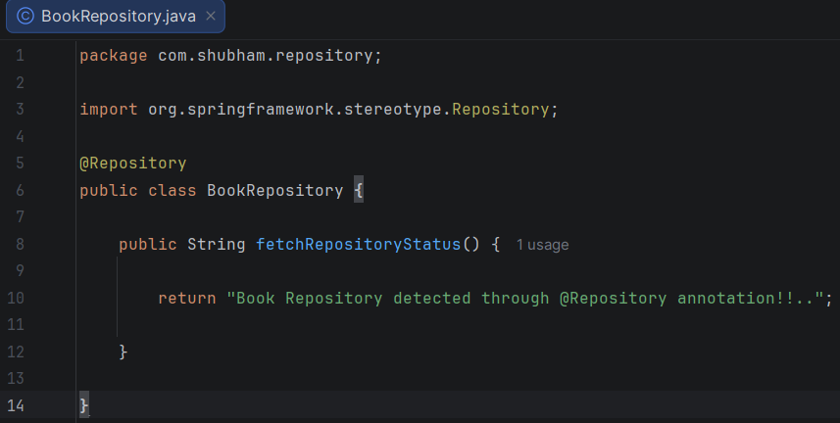

- BookService.java
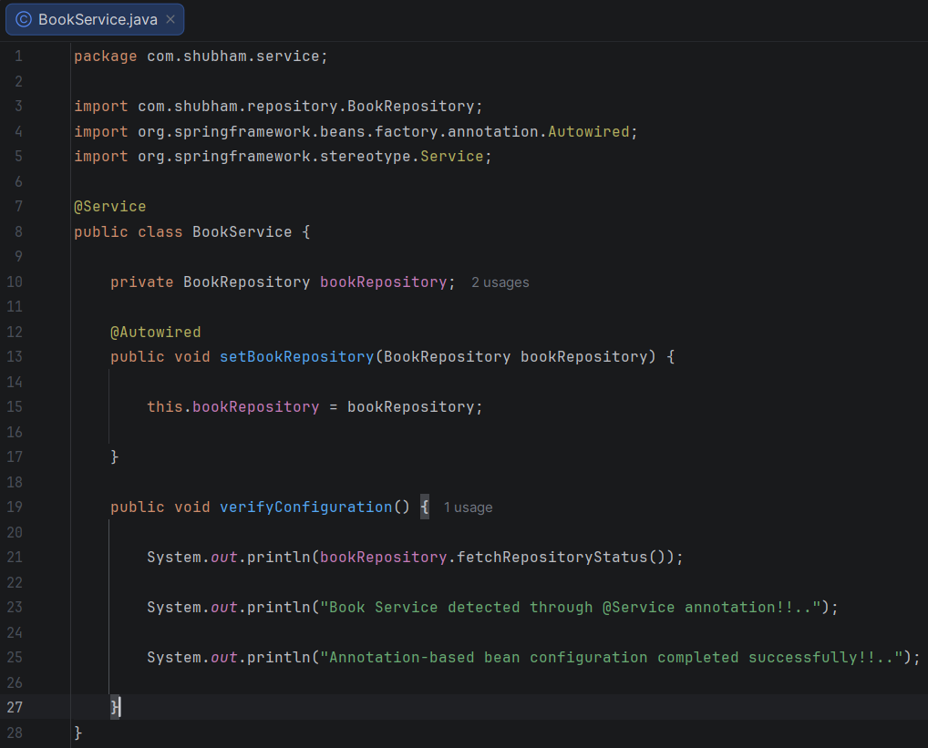

- applicationContext.xml
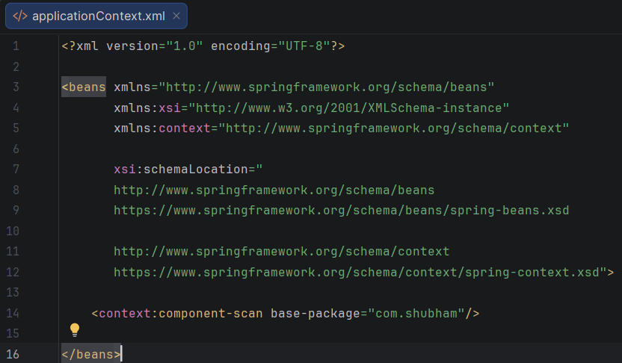
- LibraryManagementApplication.java
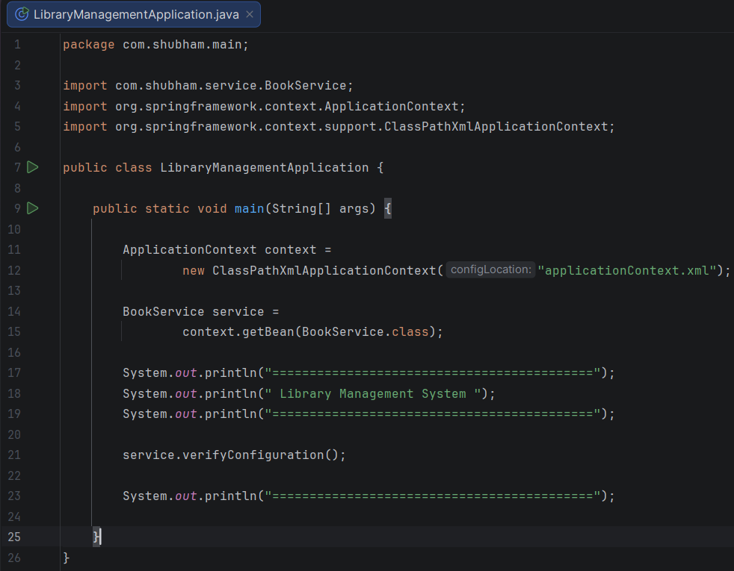

Result
The Spring beans were successfully configured using annotations. The Spring IoC Container automatically detected the annotated classes, injected the required dependencies, and executed the application successfully.

Conclusion
The exercise successfully demonstrated annotation-based bean configuration using @Repository, @Service, @Autowired, and component scanning. This approach simplifies XML configuration while improving the maintainability and readability of Spring applications.

